Design Specification Document

Project & Job Management

Document version : 1.0

Version Summary
Version | Date | Authors | Comments
1.0 |  | Ilyaad | Creation
1.1
1.2

Functional Specifications

Context (Storyline) / Business Case
Bioculture’s core business relies on the breeding and sale of Non-Human Primates (NHP). These activities require significant investment in infrastructure, vehicles, and other machines. As part of its annual planning exercise, Bioculture allocates substantial budgets that are executed and consumed through Projects.
Maintenance activities, construction-related procurement, medical procurement, and site upgrade initiatives are all initiated through Projects. The purpose of a Project is to group all Jobs related to a specific business objective, thereby consolidating all associated expenses, costs, and bills of material required for the successful completion of the Project. This approach enables improved cost control, financial visibility, and structured project governance across the organization.

Functional Requirements
Ref# | Details
FR-Project_Job-001 | Support the concept of Project record grouping multiple jobs
FR-Project_Job-002 | Classify the project as OPEX and CAPEX if subsidiary is BCM
FR-Project_Job-003 | No Classification of project is subsidiary is Franklin
FR-Project_Job-004 | Support the creation of job from the project window
FR-Project_Job-005 | CAPEX Project is inactive until Finance approves it. No creation of job until Project is approved.
FR-Project_Job-006 | Support the definition of budget overrun thresholds expressed as a percentage for CAPEX Project.
FR-Project_Job-007 | Ability to classify CAPEX project as: Construction, Assembly of Machines & Deployment of Machine.
FR-Project_Job-008 | Ability to classify OPEX project as: Replenishment & Maintenance
FR-Project_Job-009 | Categorize Job of OPEX Project as: Preventive Maintenance, Corrective Maintenance, Purchase-Request  Categorize Job of CAPEX Project as: Project phase
FR-Project_Job-010 | CAPEX Job categorizes through Job Type which determines the Asset Type.
FR-Project_Job-011 | Ability to track duration for OPEX Job and CAPEX Job.
FR-Project_Job-012 | Provide a consolidated view to manager to assign job to resources.
FR-Project_Job-013 | Ability to create a PO of type Labor/sub-contractor from Job.
FR-Project_Job-014 | Support the creation of Job for users without NetSuite access.

Flow Diagram / Sitemap / Application Flow
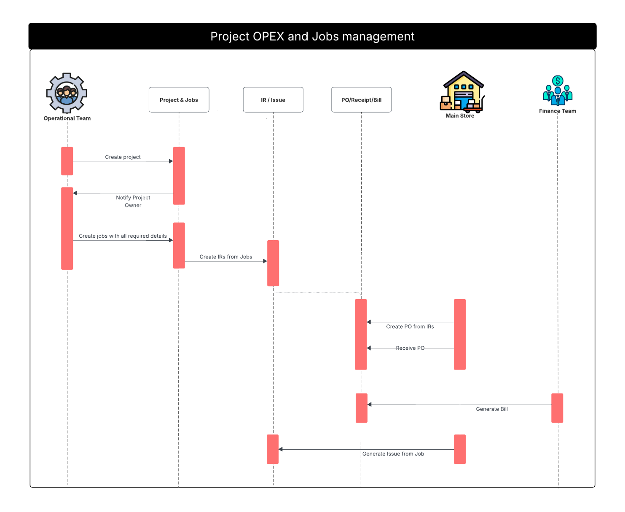
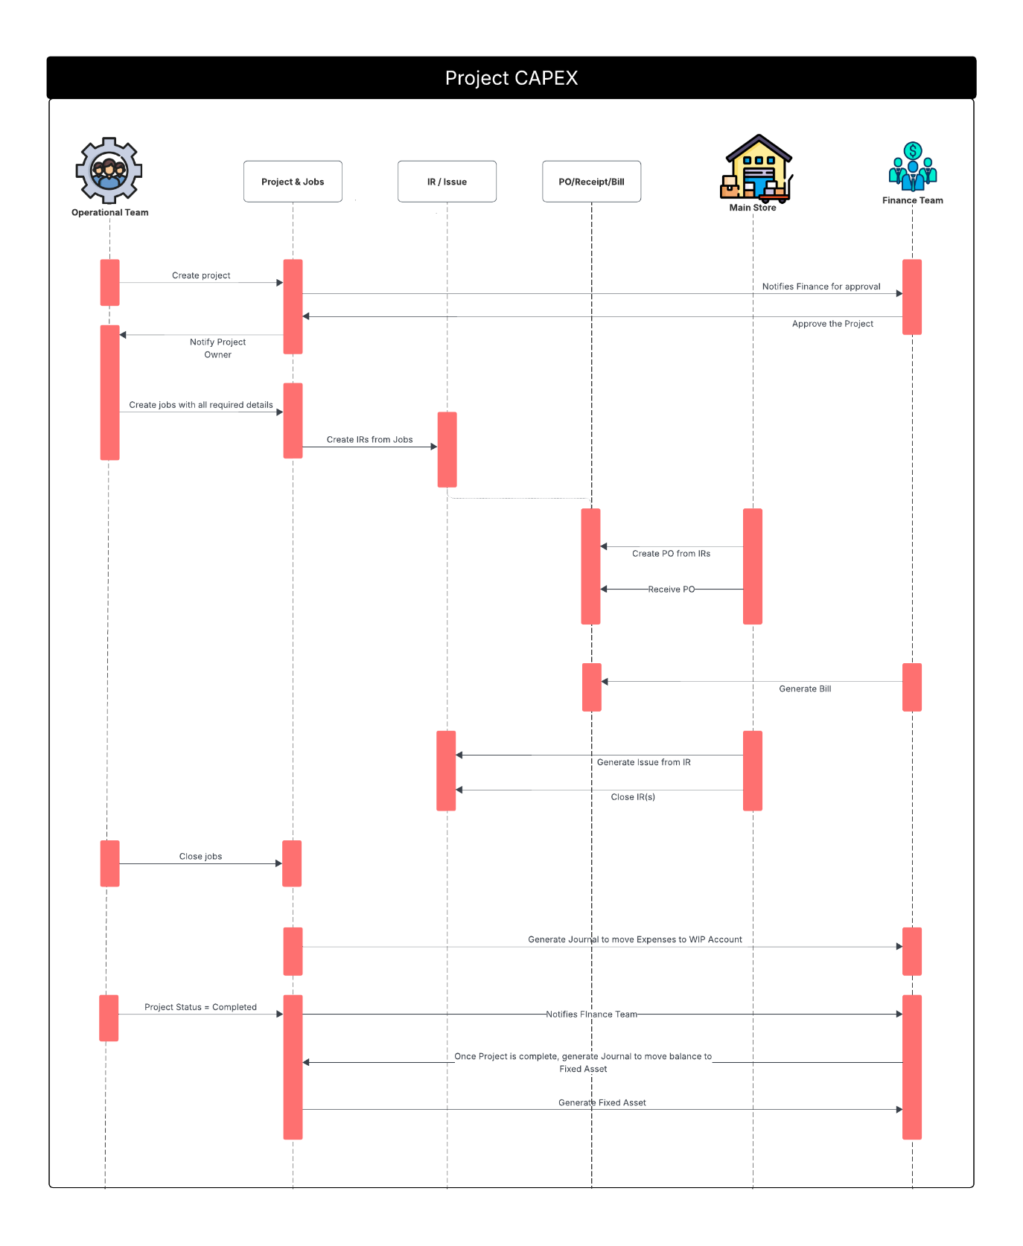

Risk / Assumptions
- Job is link to 1 or zero Machine
- Job is link to one site, all sites or no site
- Job cannot be closed if Internal Requisition is open
- Job is closed manually by Owner or its supervisor
- Only one preventive Job for a machine can be open at a time.
- Internal Requisition can only be created from a job
- A Job is link to only one project.
- The project is restricted to 1 site and 1 department.
- A project will not be permanently open. Either until completion of its jobs or end of year.
- A project is not completed/closed until associated jobs are closed.
- Job is closed only when associated IR(s) is/are fully closed (all lines are processed)
- Work Order line is associated to a single job.
- If BCM buys the services of subcontractor for painting and the painting includes several sites. The PO of type Work Order should have one line for each site/job so that the cost impacts the correct analytics.
- Only through Project (CAPEX) can machines (that are FA) be issued.
- A CAPEX Project is only for assembly of one type of machine.
- For example, A single project can’t assemble both water pressure and vacuum cleaner.
- Not all Machines will become Fixed Asset. To be defined on Item record.

Technical Specification

Proposed Solution
Ref# | Details
FR-Project_Job-001 | Support the concept of Project record grouping multiple jobs | Custom Record. See Schema diagram
FR-Project_Job-002 | Classify the project as OPEX and CAPEX if subsidiary is BCM | Custom field. See Schema diagram
FR-Project_Job-003 | No Classification of project is subsidiary is Franklin | Use of Workflow to hide field depending on subsidiary
FR-Project_Job-004 | Support the creation of job from the project window | Job is child of project. Standard of behavior of custom record.
FR-Project_Job-005 | CAPEX Project is inactive until Finance approves it. No creation of job until Project is approved. | Approval via workflow.
FR-Project_Job-006 | Support the definition of budget overrun thresholds expressed as a percentage for CAPEX Project. | Custom field. See Schema diagram
FR-Project_Job-007 | Ability to classify CAPEX project as: Construction, Assembly of Machines & Deployment of Machine. | See Schema diagram
FR-Project_Job-008 | Ability to classify OPEX project as: Replenishment & Maintenance | See Schema diagram
FR-Project_Job-009 | Categorize Job of OPEX Project as: Preventive Maintenance, Corrective Maintenance, Purchase-Request  Categorize Job of CAPEX Project as: Project phase | See Schema diagram
FR-Project_Job-010 | CAPEX Job categorizes through Job subtype which determines the Asset Type. | Custom record linking Job Subtype with Fixed Asset Type. Job Subtype values are:
FR-Project_Job-011 | Ability to track duration for OPEX Job and CAPEX Job. | See Schema diagram
FR-Project_Job-012 | Provide a consolidated view to manager to assign job to resources. | Feature of Field Service Module
FR-Project_Job-013 | Ability to create a PO of type Labor/sub-contractor from Job. | Custom field of PO ‘PO type’ values are Materials & Machines, Medical, Food & Labor & Subcontractor
FR-Project_Job-014 | Support the creation of Job for users without NetSuite access. | Feature of Job Module

Data Schema
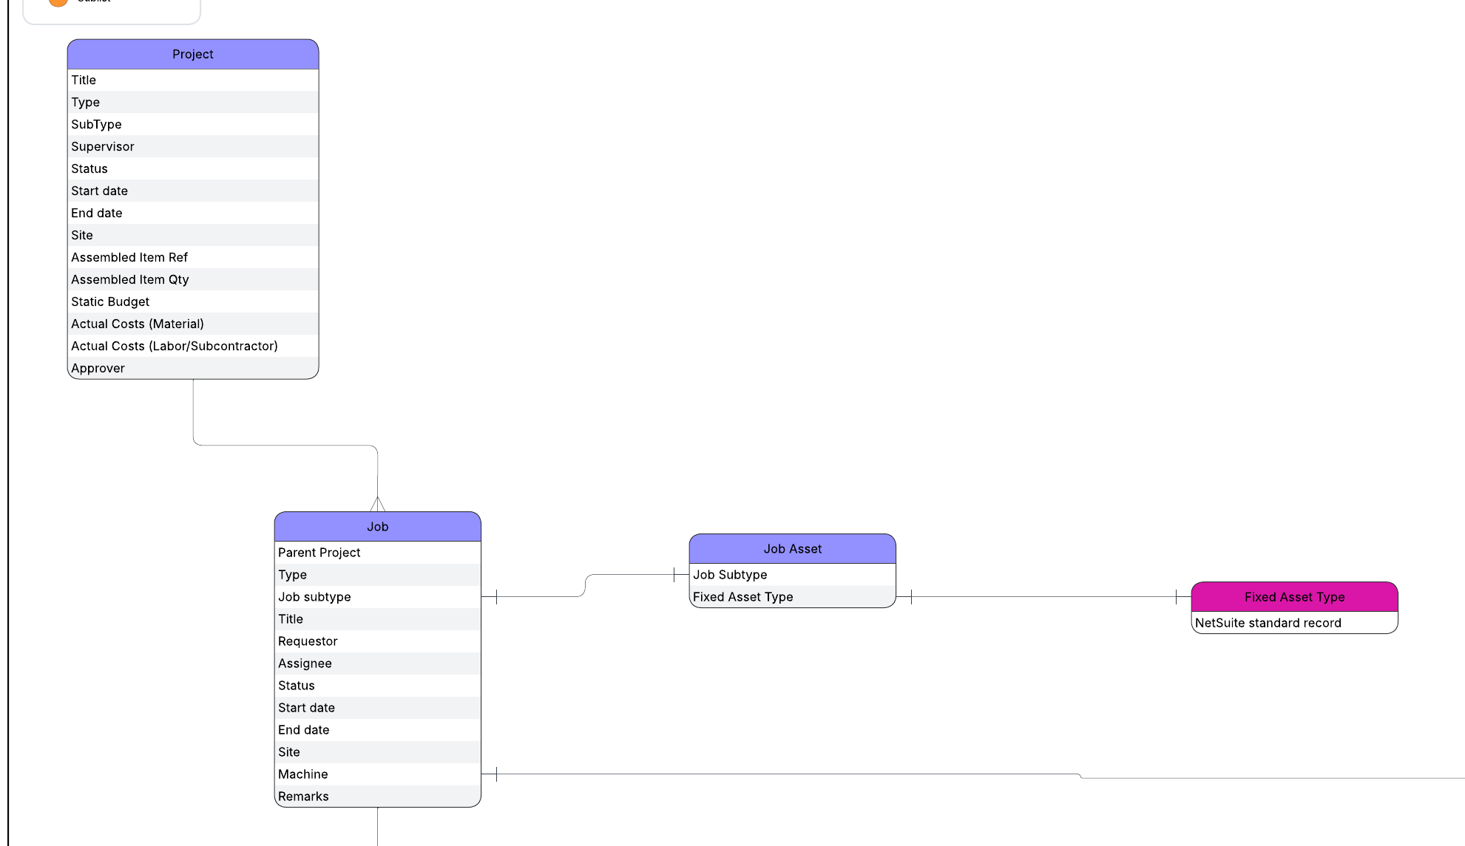

Pseudocode / Logic / Code map
N/A

Related documents
Project-To-Cost and Job Management: Bioculture - DSD - Project-To-Cost and Job Management.docx
Job and IR Management: Bioculture - DSD - Jobs and IR Management.docx

